**Assessment 2– Group work**

**Task 1**

You ae to use the group you were assigned to do this assignment. You are required to develop a UI similar to the following using HTML, CSS and JS.

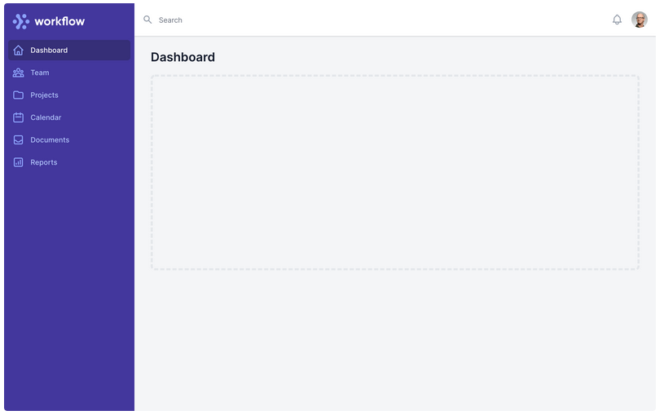

**Task 2**

One of the summared information that is used by managers inclued charts (pie, bar, scatter etc.). management information systems pull data that has been collected by transaction processing sytems and provide summaries and reports to middle level managers. As developers we are supposed to have ability to develop applications that summarise information using the various vusual tools.

Intead of getting data from a database, you are required to use dummy data in modules like in the following diagram.

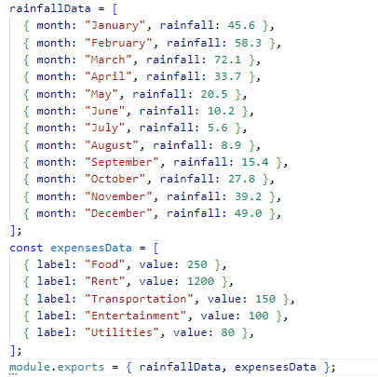

Import the data (use your own dummy data) in your server script and send to the view where you are to use it to create at least three four different types of charts using chart.js library. Chart.js is an open-source JavaScript library that allows developers to create interactive, visually appealing charts and graphs on web pages. It provides a simple and flexible API for creating various types of charts, including line charts, bar charts, pie charts, and more. Chart.js is widely used for data visualization in web applications and is known for its ease of use and flexibility. You can learn more about using chart.js using the following links.

* <https://www.w3schools.com/ai/ai_chartjs.asp>
* <https://www.chartjs.org/docs/latest/samples/line/line.html>
* <https://www.tutorialspoint.com/chartjs/chartjs_syntax.htm>

**Submission**

* The assignment is due on 26th September 2023 23:59
* Create a repository and submit a link to the repo